Exercise 2
Develop and compare CLI, GUI, and Voice UserInterfaces (VUI) for the same task and assess usersatisfaction using Python (Tkinter for GUI, Speech
Recognition for VUI), Terminal

AIM:
- The aim is to develop and compare Command Line Interface (CLI), Graphical User Interface
- (GUI), and Voice User Interface (VUI) for the same task, and assess user satisfaction using
- Python (with Tkinter for GUI and Speech Recognition for VUI) and Terminal.
PROCEDURE:
- CLI
tasks = []
def add_task(task):
tasks.append(task)
print(f"Task '{task}' added.")
def view_tasks():
if tasks:
print("Your tasks:")
for idx, task in enumerate(tasks, 1):
print(f"{idx}. {task}")

else:
print("No tasks to show.")

def remove_task(task_number):
if 0 < task_number <= len(tasks):
removed_task = tasks.pop(task_number - 1)
print(f"Task '{removed_task}' removed.")
else:
print("Invalid task number.")

def main():
while True:
print("\nOptions: 1.Add Task 2.View Tasks 3.Remove

Task 4.Exit")

choice = input("Enter your choice: ")
if choice == '1.':
task = input("Enter task: ")
add_task(task)
elif choice == '2.':
view_tasks()
elif choice == '3':
task_number = int(input("Enter task number to

remove: "))

remove_task(task_number)
elif choice == '4':
print("Exiting...")
break
else:
print("Invalid choice. Please try again.")

if name == " main ":
main()
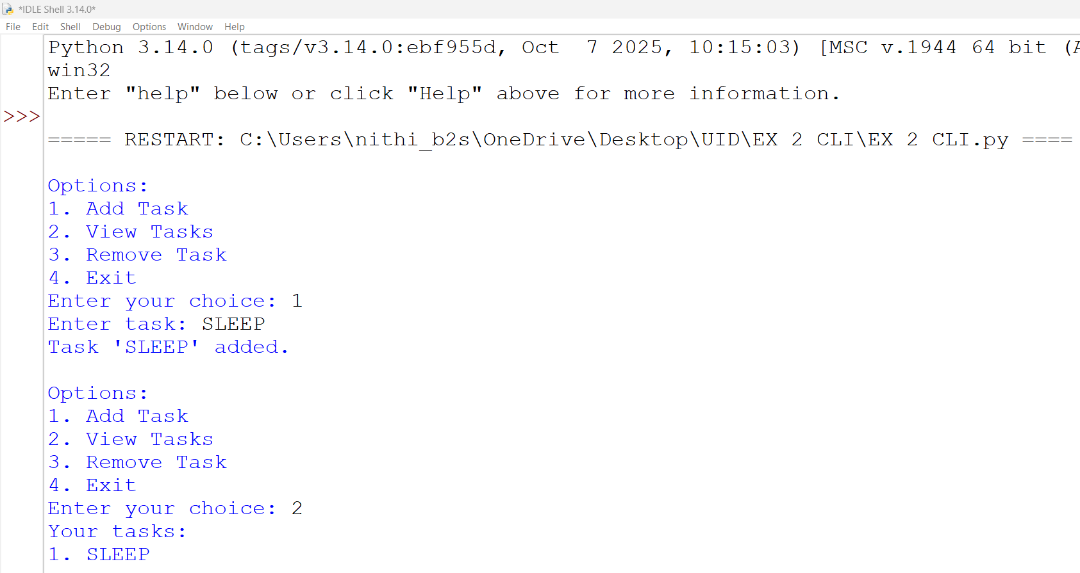
Sample Output:

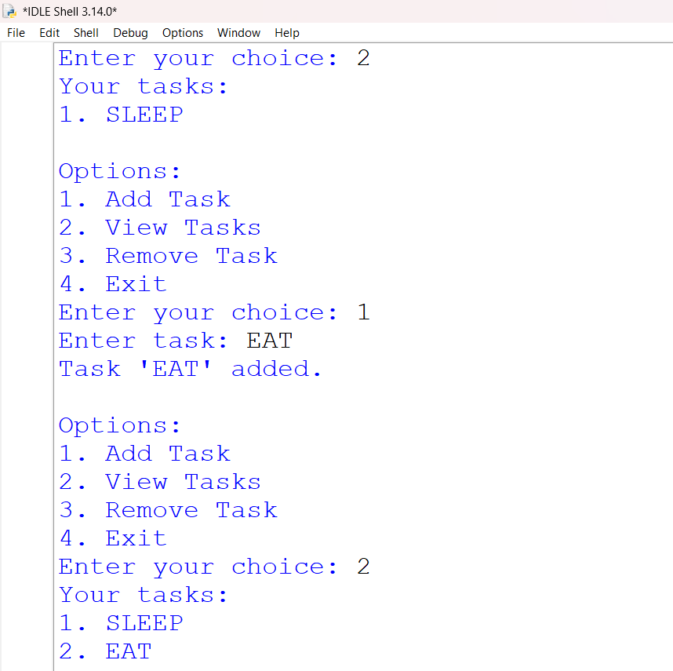
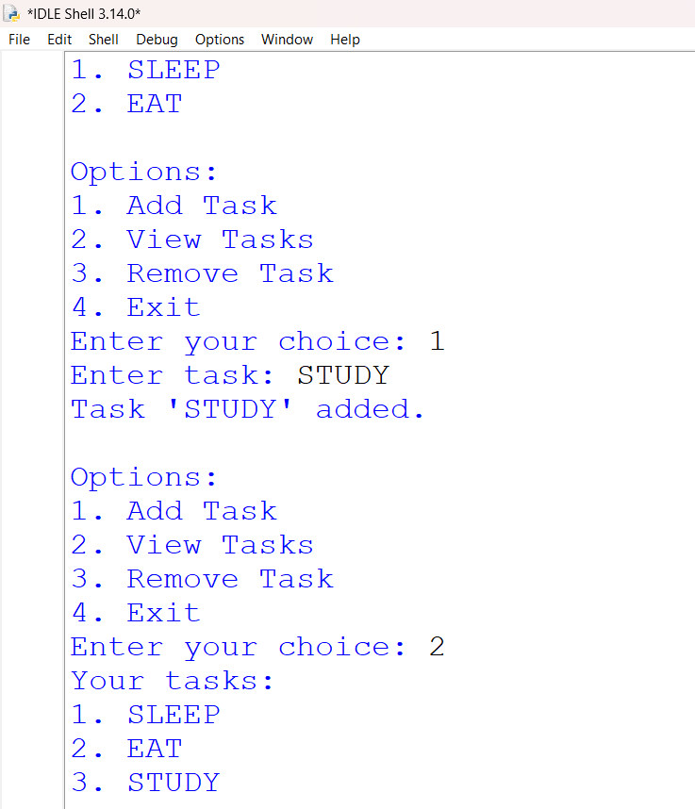

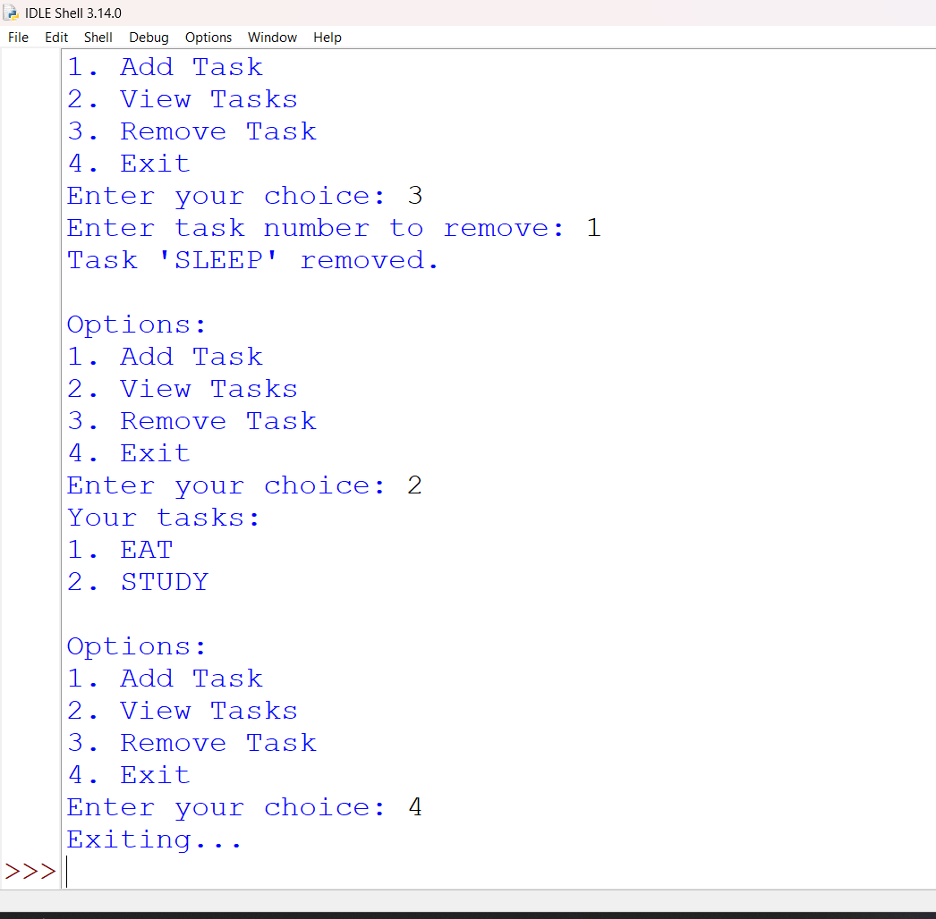

GUI
import tkinter as tk
from tkinter import messagebox
tasks = []
def add_task():
task = task_entry.get()
if task:
tasks.append(task)
task_entry.delete(0, tk.END)
update_task_list()
else:
messagebox.showwarning("Warning", "Task cannot be

empty")
def update_task_list():
task_list.delete(0, tk.END)
for task in tasks:
task_list.insert(tk.END, task)

def remove_task():
selected_task_index = task_list.curselection()
if selected_task_index:
task_list.delete(selected_task_index)
tasks.pop(selected_task_index[0])

app = tk.Tk()
app.title("To-Do List")
task_entry = tk.Entry(app, width=40)
task_entry.pack(pady=10)
add_button = tk.Button(app, text="Add Task",
command=add_task)
add_button.pack(pady=5)

remove_button = tk.Button(app, text="Remove Task",
command=remove_task)
remove_button.pack(pady=5)
task_list = tk.Listbox(app, width=40, height=10)
task_list.pack(pady=10)
app.mainloop()
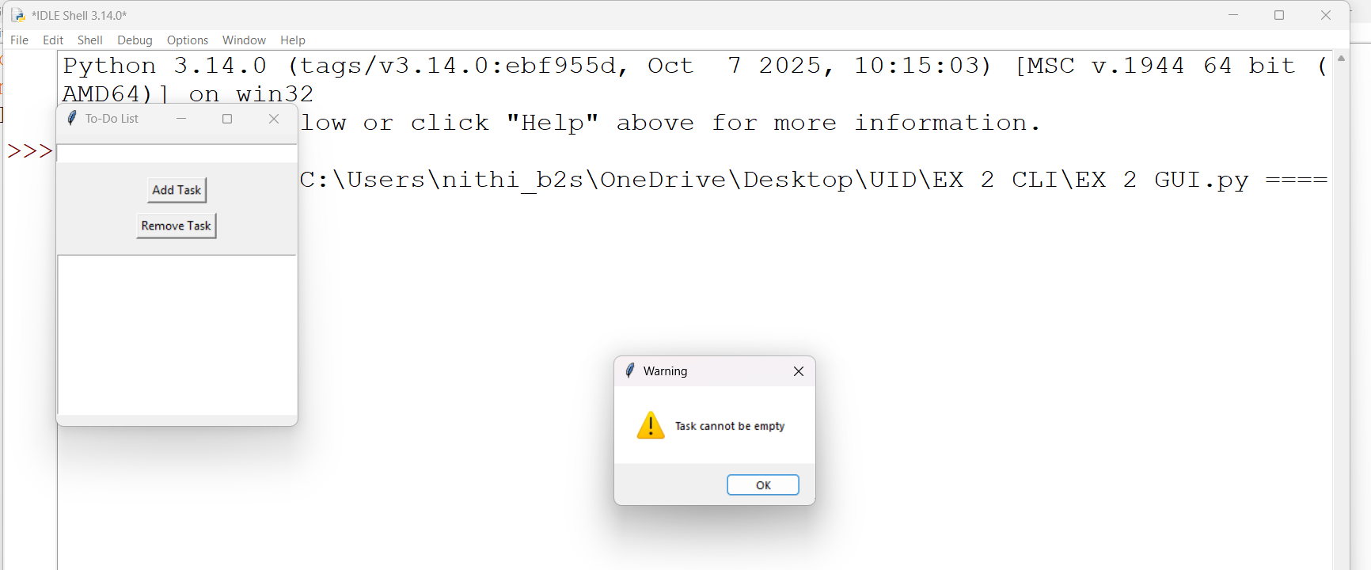
Sample Output:

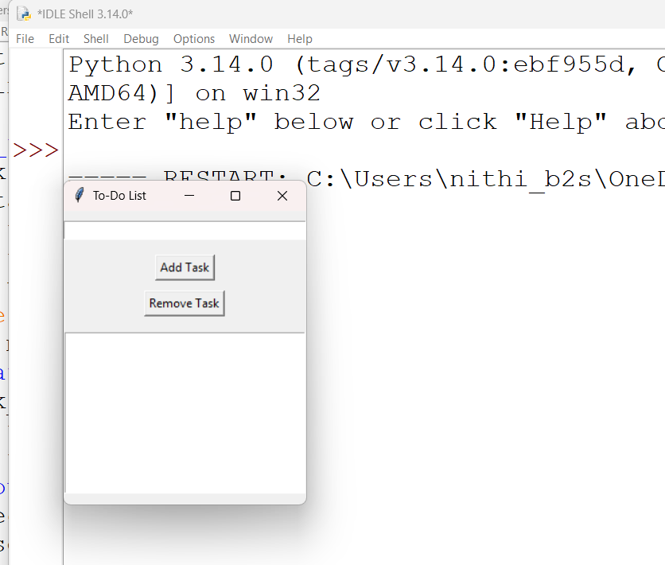

iii) VUI (Voice User Interface)
speech_recognition library for voice input and the pyttsx3 library for text-to-speech
output. Make sure you have these libraries installed (pip install SpeechRecognition pyttsx3).

import speech_recognition as sr
import pyttsx3
tasks = []
recognizer = sr.Recognizer()
engine = pyttsx3.init()
def add_task(task):
tasks.append(task)
engine.say(f"Task {task} added")
engine.runAndWait()
def view_tasks():
if tasks:
engine.say("Your tasks are")
for task in tasks:
engine.say(task)

else:
engine.say("No tasks to show")
engine.runAndWait()
def remove_task(task_number):
if 0 < task_number <= len(tasks):
removed_task = tasks.pop(task_number - 1)
engine.say(f"Task {removed_task} removed")
else:
engine.say("Invalid task number")
engine.runAndWait()
def recognize_speech():
with sr.Microphone() as source:
print("Listening...")

audio = recognizer.listen(source)
try:
command = recognizer.recognize_google(audio)
return command
except sr.UnknownValueError:
engine.say("Sorry, I did not understand that")
engine.runAndWait()
return None

def main():
while True:
engine.say("Options: add task, view tasks, remove

task, or exit")

engine.runAndWait()
command = recognize_speech()
if not command:
continue
if "add task" in command:
engine.say("What is the task?")
engine.runAndWait()
task = recognize_speech()
if task:
add_task(task)

elif "view tasks" in command:
view_tasks()
elif "remove task" in command:
engine.say("Which task number to remove?")
engine.runAndWait()
task_number = recognize_speech()
if task_number:
remove_task(int(task_number))

elif "exit" in command:
engine.say("Exiting...")
engine.runAndWait()
break
else:
engine.say("Invalid option. Please try again.")
engine.runAndWait()
if name == " main ":
main()

